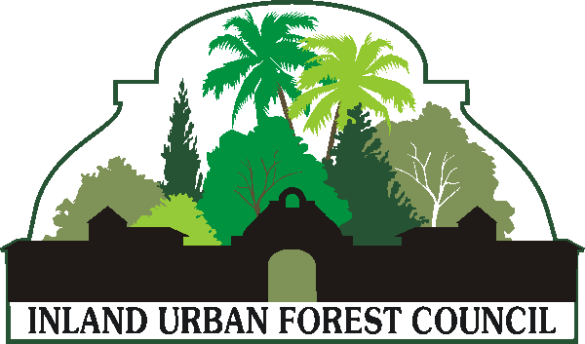

The Secret Life of Wood
An IUFC Workshop
Thursday, March 19
Sims Tree Learning Center
6111 Appaloosa Avenue
Jurupa Valley, CA
310.562.4904
Agenda

8am – Registration starts

8:30 –9:30am, Biology, Wood’s Role in a Healthy Tree, Susan Sims
Wood health is directly related to biology. The more you understand, the better decisions can be made. The basics of biology is often overlooked or forgotten, yet vitally important in management. Susan Sims will share a practical approach.

BREAK

9:45am – 10:45am, Response Growth (nature and biology of reaction wood, wound wood, and adaptive growth), Dr. Fred Roth
Trees produce unusual patterns of growth in response to differing conditions and forces. The presentation by Dr. Fred Roth will distinguish between different types of response growth, which are often confusing. He will also discuss the role of response growth in strengthening of trees, directing growth, and assessing risk of failure.

10:45 – 11:45am, Decay and Rot in Declining Trees, Rebecca Latta
Decay can be tricky to evaluate. An understanding of how different types of decay affect wood quality can be a complicated task. Evaluation of decay can be a simple or sometimes difficult process. Rebecca Latta will share her expertise on this important subject.

LUNCH (Provided by IUFC)
The IUFC will be competing again with its annual chili cook off. Dr. Roth took first place last year with his chocolate chili. You don't want to miss this one.

12:30 – 1:30pm, Wood Characteristics and Products, Andy Trotter
Wood waste reduction is an important goal in urban forest management. Learn about wood’s characteristics and how to turn would-be waste into valuable products.
Andy Trotter is at the forefront of this topic.

1:30 – 2:30pm, Alternative Uses for Wood, John Mahoney
Just for fun, expert chainsaw carver John Mahoney will demonstrate how urban wood can be transformed into a fun project or even collectable pieces of art. If chain saw carving is on your bucket list, you will not want to miss this demonstration.

Cost: $75
ISA CEUs will be available.
Register at:
https://www.eventbrite.com/e/the-secret-life-of-wood-tickets-15594326049

