**University of Redlands Urban Forest Strategic Management Plan**

# 

**Dates covered by plan:** 2012 - 2032 This is a long-range plan to assist in overall tree care, maintenance and urban forest development.

# 

**Prepared for:** University of Redlands Campus Community

# 

**Prepared by:** Jeff McClintock, Manager of Grounds and Waste Management and Jennifer Sorenson, Associate Director of Facilities Management

# 

**Plan approval date and/or date of final draft: November 7, 2012**

# 

# 

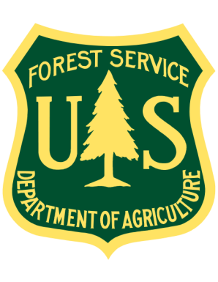

**Funding provided by the**

**USDA Forest Service**

**Through the California Department of Forestry and Fire Protection**

**Urban and Community Forestry Program**

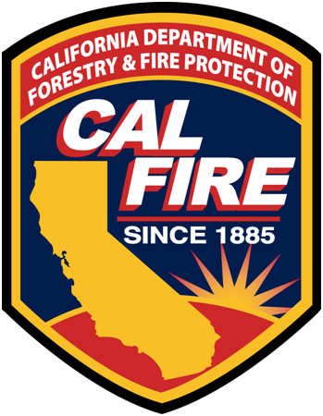

# Executive summary

This Urban Forest Management Plan is designed to characterize the University of Redlands urban forest. Data from tree inventories, University archives, and urban forest best practices have been combined to create a strategy for management of the University urban forest. This plan includes information on the history of the current urban forest, how it has developed and been cared for. In addition the current status of the forest has been assessed to determine its overall health. Finally a strategic plan has been developed for how the University should move forward with respect to tree care.

In order for the University of Redlands to develop a Sustainable Urban Forest we need to utilize best management practices to create a healthy quality environment for trees and shrubs. The development of these guidelines will help prevent many of the practices that have been detrimental to a healthy sustainable urban forest whether in the selection of quality plant stock, proper protection of trees on a construction site or in the everyday care and pruning of our valuable tree resource.

# Table of Contents

# Vision and Mission 5

# Introduction 6

# Scope 8 Status of the Urban Forest 8

**Environmental Context 9**

**Strategic Plan 14**

**Appendix**

# Vision statement

The University of Redlands’ urban forest offers its students, faculty, staff and members of the Redlands community a place of beauty, reflection, and quiet contemplation but also a refuge for wildlife that is abundant in the area.

The University’s vision is to build a diverse urban forest in both age and species that will enhance the health of the forest creating both a healthy and sustainable environment for our campus community to enjoy for generations to come.

**Mission statement**

It is the mission of the University Facilities Department along with the Tree Committee, and Campus Administration to maintain a healthy, sustainable forest.

We must make certain that our forest is diverse enough in both age and species to prevent any catastrophic attacks on our tree population.

We must ensure that our forest is adequately funded to maintain proper pruning, mitigation of pests, and planting of new specimens.

We must also implement best management practices that are incorporated into every aspect of campus life that will preserve and protect this valuable campus asset.

**Introduction**

## Overview

**Historical context**

 Our forest is a combination of native riparian trees and plant material along the historic Zanja, an irrigation canal, which was built by Native Americans over a century ago along with a diverse urban forest that has developed on the University's grounds since its inception in 1907.

The landscape has been at the heart of the University of Redlands since its founding. University President Jasper Newton Field and first campus architect Norman Foote Marsh emphasized the importance of the landscape as an integral part of the campus plan. In 1907 they developed a basic design for the campus that was developed around a quadrangle that they envisioned as a sunken garden. Today the "Quad" is the home to some of the oldest trees on the campus, California Live Oak trees that are nearing 100 years old.

The campus romance with trees does not end at the Oaks, the region’s importance in the Citrus industry did not go unnoticed by the University. The City of Redlands at the peak of production in 1940 claimed 10,000 acres and 225 packing houses producing some of the most famous Washington Navel Oranges in the world. In fact the University planted citrus groves to supplement its income in the early years of the developing campus. In 1931 most of the campus land was planted in citrus groves. In 1955 San Bernardino County had 50,000 acres of citrus, today there are less than 2,500 acres in cultivation. In 1984 the town and gown project, a group comprising both the town of Redlands and the University, installed a 3 acre Centennial Grove that thrives today.

The University has partnered with the City of Redlands to develop the banks of the Zanja with tree species that are native to the area, planting over 50 trees in 2012, in order to preserve this historic tributary. The City and University maintain a close relationship as many of the street trees along the perimeter of the campus are jointly cared for and managed by both the City and the University. The University of Redlands has been recognized as a Tree Campus USA since 2009 and the City of Redlands has been a Tree City USA since 1997. It shows an appreciation by both entities for the value of our urban forests.

The University has a history of valuing its urban forest. A 2010 advertising campaign for the University included that Redlands is a University of "Big Trees". The University uses its landscape as an outdoor classroom in Biology, Environmental Studies, Community Service, and many other disciplines. We understand that our landscape is an important part of the success of each generation of students.

**Why we need a plan**

A comprehensive Urban Management Plan:

1. Maintains the economic, environmental, and social benefits of our urban forest

2. Preserves the heritage of the University and the vision of our founders with

respect to open space

3. Improves the University’s ability to respond to emerging pest and disease issues

4. Makes more efficient use of the limited funding and personnel that are available

## Benefits provided by trees

Trees have a variety of benefits that we often take for granted. These benefits include environmental, economic, and psychological. All of the benefits of trees play an important part of the mission of the University of Redlands to educate the hearts and minds of the next generation of students.

The environmental benefits of trees often get taken for granted but these are very important to the campus community and the greater Inland Empire region. There have been several studies that show that trees improve air quality. Specifically they intercept particulate matter and absorb gaseous contaminants in the air. This helps to reduce smog formation in the atmosphere. More recently it has been identified that trees are beneficial in carbon sequestration and in the reduction of greenhouse gases in the atmosphere. During photosynthesis trees remove carbon dioxide from the air. Our inventory of over 1500 trees on campus and close to 1,000,000 sqft of canopy cover greatly reduce the amount of carbon in the atmosphere.

A further environmental benefit is the conservation in energy that is provided through shade. Trees intercept solar radiation, reducing the thermal gain in temperature to buildings, parking lots, and roads. In addition trees cool the air through transpiration and can create micro climates in which the air flow and wind patterns are impacted as well. Well placed trees reduce the need for air conditioning, and can extend the life of building components and pavement.

Trees are also important in improving water quality, reducing storm water runoff, and erosion. Lastly trees provide a habitat for wildlife on campus including mammals such as squirrels, and raccoons, birds, insects and reptiles.

In addition to their environmental benefits, trees offer social and psychological benefits as well. On campus the Quad provides a central place for gathering, socializing and learning. The beauty of the Quad is attractive to students and visitors alike and is central to the overall impression of anyone coming to the campus. The power of nature to have a restorative and calming effect has been well documented in the literature. Steve Kaplan wrote in 1993 "an important component of nature's special role in people's lives is nature's capacity to restore the mind and spirit, to allow one to recover from fatigue and to become once again comfortable, civil and effective." In a later study in 1998 Kaplan et al. found "those office workers with views of natural elements experience less job pressure and a greater job satisfaction than colleagues with no view or views of the built environment." A 2001 study by Kuo and Sullivan "observed that vegetation may mitigate psychological precursors to crime, such as irritability, inattentiveness, and impulsive behavior. The restorative power of nature in cities reduces these precursors." Certainly the natural environment plays a role in educating the hearts and minds of our students.

The final tree benefit that should not be overlooked from a business perspective is the economic benefit of trees. Several studies have concluded that areas with larger trees, regardless of species, increase property values from 5-8%. Planting and caring for the urban forest is beneficial to the Campus Community and is another way that the University can support our larger community.

**Scope of the plan**

**Planning horizon**

This plan is designed to manage the Campus Urban Forest over the next 20 years.

**Relationship to other planning documents**

UFMP is designed to fit within the framework of the Campus Master Plan Document.

The UFMP incorporates the components of the existing Tree Care Plan as it relates to best practices for tree care and maintenance on campus. Other guidelines such as the standards for tree care in construction are also incorporated here.

# Status of the urban forest

## Historical context

Founded in 1907 the University has slowly grown over the decades into the tree lined campus that it is today. The Baptist College envisioned by city founders has grown and changed throughout the decades. The present day Quadrangle that once grew vegetables during WW1 is now the home of the stately Coast Live Oaks. Small *Washingtonia robusta*, Mexican Fan Palms, that were planted then are now the 100 foot tall specimens we see today. The *Quercas agrifolia* in the Quad are pictured in the office of the current president as small saplings in the 1920 era photo making many of them near 100 years old now.

The Greek theater that opened in 1927 was built when the Zanja, an irrigation canal developed by Native American Indians decades earlier, actually flowed in front of the theater. Now flowing behind the theater it is the focus of both the City and the University to return it to its more natural habitat. In 2012 over 50 California Sycamores and Alders were planted to help return the portion of the Zanja that runs through the campus to this state.

While it is important for the stewards of the University grounds to maintain landscapes that have a sense of the past it is also our responsibility to maintain trees that are safe. Considering the current amount of students, staff and members of the community that populate the University it is necessary to remove many trees that can be of high risk like the many dangerous Eucalyptus specimens that have been removed during recent construction and replaced with more diverse and suitable species.

That being said with the campus being over 100 years of age there is a historical legacy that we wish to preserve. Throughout the decades many styles and fashions of landscape architecture have come and gone and while it is our desire to move in the direction of sustainability we must also keep in mind our heritage and try and maintain many of the old designs when prudent.

**Environmental context**

The University of Redlands is located in the U.S. Department of Agriculture plant hardiness zone 9b. The temperature parameters for Hardiness Zone 9 extend from 20°F to 30°F (or -7°C to -1°C). These temperature parameters indicate the minimum temperature that a plant can withstand in that zone. Plants that flourish in Zone 9 have a need for long growing seasons and also grow well in very mild winters.

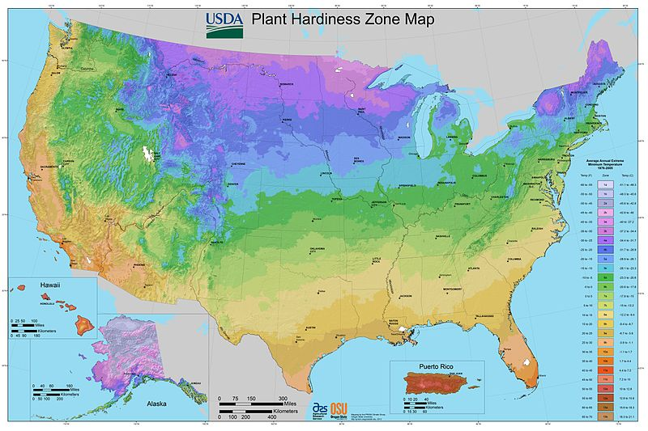

## The name Redlands comes from the clay soil found in the region. Clay [soils](http://patwelsh.com/wpmu/blog/category/soils/) can bake hard on top and crack open in hot, dry, weather. Clay [soil](http://patwelsh.com/wpmu/blog/category/soils/) is heavy and difficult to dig, but it is rich in minerals. Some clay [soils](http://patwelsh.com/wpmu/blog/category/soils/) don’t drain well, but on the other hand well-amended clay has the benefit of holding moisture, a big benefit in a dry climate.

## Today the University of Redlands has a mix of soil types but primarily we work with sandy loam. Loam is a combination of clay, silt and sand.  Sandy loam holds water, drains well, but compacts. One of the primary challenges for our urban forest is compaction of the soil surrounding our trees. This compaction has many sources including, heavy foot traffic and construction.

## Tree resource assessment

### A comprehensive tree inventory was conducted in 2010 and provides us with an understanding of the campus tree population. Through this inventory we were able to discern the number and species of trees that make up our urban forest as well as their relative size, age, and health. We have included summary data from this inventory to provide context as to the current state of the University of Redlands urban forest.

The tree inventory identified two key issues that are important to the sustainability of the University Urban Forest, the budget shortfall and the lack of age diversity. The tree inventory documented the health of 1,400 trees on the University campus, and did not include many of the street trees which we also currently maintain. When evaluating the budget for tree care and maintenance we are only able to maintain 10% of these trees annually. In addition what we found is that over time we are spending most of our funds maintaining the same 10% of trees. What this really highlighted for us is that 90% of the urban forest is currently being neglected.

The second issue that became apparent through our inventory is the lack of species and age diversity on campus. As we evaluated various sections of campus we identified that there are some sub-sections of campus with no age or species diversity, most notably the main quadrangle which features 100 year old *Quercas agrifolia.* Although these trees are highly valued by the University there has been little to no succession planning.

**Population Summary (Table 1)**

**Relative Tree Health (Table 2)**

**Tree Benefits and Value**

**Table 3**





**Table 4**

## Management

Primary responsibility for the care and maintenance of the campus urban forest rests with the Facilities Management department. However, there are many other campus departments that may be involved in various aspects of tree work on campus.

### Summary of management responsibilities

|  |  |  |  |  |  |  |
| --- | --- | --- | --- | --- | --- | --- |
| Activity | Activity subclass | Arborist | Grounds and Waste Management | Construction Management | Student Groups | Other-specify |
| Planting | New sites |  |  | X | X |  |
|  | Replacement plantings |  | X |  |  |  |
| Pruning | Scheduled | X | X |  |  |  |
|  | Storm/emergency |  | X |  |  |  |
|  | Utility clearance |  | X |  |  |  |
|  | Street/equipment clearance |  | X |  |  |  |
| Tree removal | Hazard trees | X | X |  |  |  |
|  | Clearance (for flood control, fire safety, etc) |  | X |  |  |  |
| Root system work | Sidewalk/curb repair and replacement |  | X |  |  |  |
|  | Excavation for utilities |  |  | X |  |  |
|  | Construction |  |  | X |  |  |
| Outreach/ education | Campus Community |  | X |  | X | Academic Areas |
|  | Contractors |  | X | X |  |  |

### Summary of ordinance, policies, and plans already in place

|  |  |  |  |  |
| --- | --- | --- | --- | --- |
| Tool | Tree Installation | Tree Protection | Tree Care and Maintenance | Tree Selection |
| Construction Standards | X | X |  |  |
| Contractor Guidelines |  | X |  |  |
| Campus Tree Care Plan |  |  | X |  |
| Tree Selection Guidelines |  |  |  | X |
| City of Redlands Approved planting list |  |  |  | X |

# Strategic Plan

### Issues and needs

#### Tree resources

The University of Redlands has limited tree species and age diversity. This limitation makes the Campus urban forest susceptible to infection from pests and can have catastrophic consequences. It is important that we focus on species diversity when considering new plantings. Unfortunately we often plant what we know and do not consider various species and their suitability to the area being planted. Age diversity is another problem most prominently displayed on the University's Quad. The Coastal Live Oaks were all planted nearly 100 years ago and as a result the area has very few young trees ready to replace trees as they die off.

One aspect of our campus culture that has an adverse effect on the tree population is the interest in planting trees vs. caring for, or maintaining existing tree populations. Student groups in particular are typically not interested in dedicating an existing tree, they want to plant more. In many cases areas of campus are overly planted, contributing to adverse health of the tree population as trees fight for limited space. There is a need to develop a process by which new trees are evaluated regarding space, type and function to ensure that new plantings are appropriate. We also need to encourage groups to not only raise funds for tree planting but to include funds for care beyond planting. In addition, we need to encourage the campus to adopt existing trees to help fund care and maintenance for those under funded specimens that have already been planted.

#### Management

Our campus culture is one in which everyone feels that they own the outdoor space. Tree planting is not strategically coordinated and often trees are planted with very little planning or coordination between departments. We need to create a pathway by which anyone (students, departments or construction) engaging in tree planting activities must gain approval. This will allow for appropriate evaluation of tree species, irrigation, space allocation, specimen selection, and size to ensure that trees that are planted will thrive. The final issue with new tree planting is that we need standards regarding the size and type of trees that will be planted on campus.

A primary management piece is the allocation of resources to match the tree population. Currently the care and maintenance budget for trees covers approximately 10% of the trees. Primarily this includes annual palm tree care and some work on the California Live Oaks. In addition there are no staff positions dedicated to tree evaluation, care or maintenance. Limitations to staffing and budget make it difficult to track tree health and to provide needed tree care.

#### Community

The campus environment creates unique issues with respect to the community interaction with the urban forest. We encourage our students to enjoy their outdoor learning environment, but at the same time, we need to develop guidelines to protect the existing tree resources.

### Goal 1

Maintain, preserve, conserve, and improve the existing campus urban forest to maximize ecosystem benefits provided by our tree population, (maintain air quality, reduce energy use, moderate storm water runoff, and provide a favorable environment for the campus community).

#### Objective 1.1

Develop programs for the adoption of existing tree resources instead of limiting our efforts to new plantings.

##### Actions

Create a program by which trees can be adopted and community members and groups can be recognized for tree care and maintenance work.

Identify trees on campus maps and inventories as they are dedicated or adopted.

Develop signage on campus to identify trees that are part of this program to alert the campus community to care and maintenance efforts.

Photo document tree health annually.

#### Objective 1.2

Implement best management practices for the care and maintenance of the urban forest.

##### Actions

Create tree specific maintenance and care plans for each tree species on campus which would include tree care intervals such as pruning and other maintenance activities.

Develop a schedule to ensure available financial resources are applied to the trees most in need of attention.

Develop tree removal guidelines to ensure that unhealthy specimens are removed from the campus as necessary to protect the Urban Forest as a whole.

### Goal 2

Continue to participate in the Tree Campus USA program.

#### Objective 2.1

Create meaningful participation opportunities for the Campus Tree Care Committee to increase involvement and participation beyond annual re-certification.

##### Actions

Schedule regular meetings of the Committee to review tree care activities.

### Goal 3

Coordinate all tree management activities within the campus urban forest through the Facilities Management department and the Campus Tree Committee.

#### Objective 3.1

Create a mechanism by which new plantings or removals are proposed and reviewed by the tree care committee

##### Actions

Develop policies by which tree activities can be approved through the committee.

## Monitoring plan

### Goal 1

Maintain, preserve, conserve, and improve the existing campus urban forest to maximize ecosystem benefits provided by our tree population, (maintain air quality, reduce energy use, moderate storm water runoff, and provide a favorable environment for the campus community).

|  |  |  |  |  |
| --- | --- | --- | --- | --- |
| Objective | Data Collected | Monitoring methods | Data collection frequency | Data storage |
| 1.1. Match species to sites to the greatest degree possible for new tree installations | Tree type and location on all new plantings | Tree planting log | as planted | Grounds Shop |
| 1.2. Locate new tree plantings in areas where available space matches the requirement for the tree at maturity | Aerial Photo and GPS | visual | annually | Facilities Management |
| 1.3. Develop programs for the adoption of existing tree resources instead of limiting our efforts to new plantings. | Tree maintenance activities | Inventory - iTree | periodic | Grounds Shop |

### Goal 2

Continue to participate in the Tree Campus USA program.

|  |  |  |  |  |
| --- | --- | --- | --- | --- |
| Objective | Data Collected | Monitoring methods | Data collection frequency | Data storage |
| 2.1. Create meaningful participation opportunities for the Campus Tree Care Committee to increase involvement and participation beyond annual re-certification. | Regular Meetings and Activities | Meeting minutes and attendance | as needed | Community Service Learning |

### Goal 3

Coordinate all tree management activities within the campus urban forest through the Facilities Management department and the Campus Tree Committee.

|  |  |  |  |  |
| --- | --- | --- | --- | --- |
| Objective | Data Collected | Monitoring methods | Data collection frequency | Data storage |
| 3.1. Create a mechanism by which new plantings or removals are proposed and reviewed by the tree care committee | Tree planting and removal plans | Tree planting and removal form | regularly | Grounds Shop |

# Appendix

## Construction Standards

**Tree Selection Guidelines**

**Quad Succession Plan**

# Implementation plan

### Goal 1. Maintain, preserve, conserve, and improve the existing campus urban forest to maximize ecosystem benefits provided by our tree population, (maintain air quality, reduce energy use, moderate stormwater runoff, and provide a favorable environment for the campus community).

#### Objective 1.1. Match species to sites to the greatest degree possible for new tree installations

|  |  |  |  |  |  |  |
| --- | --- | --- | --- | --- | --- | --- |
| Action number | Priority | Implementation steps | Timeline | Budget | Funding source | Responsibility |
| 1.1.1 | 1 | Develop guidelines and protocols for plantings | 1-5 years |  |  | Facilities Management |

#### Objective 1.2. Locate new tree plantings in areas where available space matches the requirement for the tree at maturity

|  |  |  |  |  |  |  |
| --- | --- | --- | --- | --- | --- | --- |
| Action number | Priority | Implementation steps | Timeline | Budget | Funding source | Responsibility |
| 1.2.1 | 1 | Evaluate space prior to all plantings | 1-5 years |  |  | Facilities Management |

#### Objective 1.3. Develop programs for the adoption of exisiting tree resources instead of limiting our efforts to new plantings.

|  |  |  |  |  |  |  |
| --- | --- | --- | --- | --- | --- | --- |
| Action number | Priority | Implementation steps | Timeline | Budget | Funding source | Responsibility |
| 1.3.1 | 3 | Develop procedure, fee structure, and advertise | 1-5 years | $1,000 | Self-funded from program | Facilities Management and Development Office |

### Goal 2. Continue to participate in the Tree Campus USA program.

#### Objective 2.1. Create meaningful participation opportunities for the Campus Tree Care Committee to increase involvement and participation beyond annual re-certification.

|  |  |  |  |  |  |  |
| --- | --- | --- | --- | --- | --- | --- |
| Action number | Priority | Implementation steps | Timeline | Budget | Funding source | Responsibility |
| 2.1.1 | 3 | Schedule regular meetings | 1-5 years |  |  | Community Service Learning |

### Goal 3. Coordinate all tree management activities within the campus urban forest through the Facilities Management department and the Campus Tree Committee.

#### Objective 3.1. Create a mechanism by which new plantings or removals are proposed and reviewed by the tree care committee

|  |  |  |  |  |  |  |
| --- | --- | --- | --- | --- | --- | --- |
| Action number | Priority | Implementation steps | Timeline | Budget | Funding source | Responsibility |
| 3.1.1 | 2 | Develop approval process for all tree work | 5-10 years |  |  | Facilities Management, Construction Management |